**OBJECTION TO PROPOSED DEVELOPMENT AT ROBERTS CLOSE (K1) APPLICATION - 18/AP/1604**

**Photographs of the local area surrounding K1 site as referenced in the objections above.**

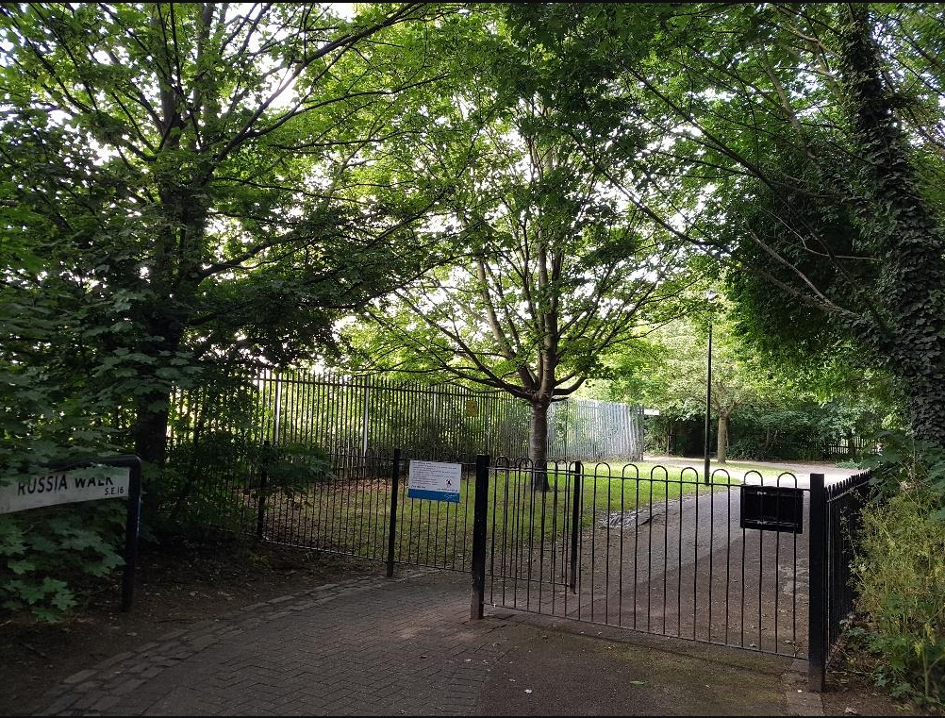

Figure 1. The light and attractive Russia Walk footpath on East Side of K1 site (K1 boundary fence in the background on left)

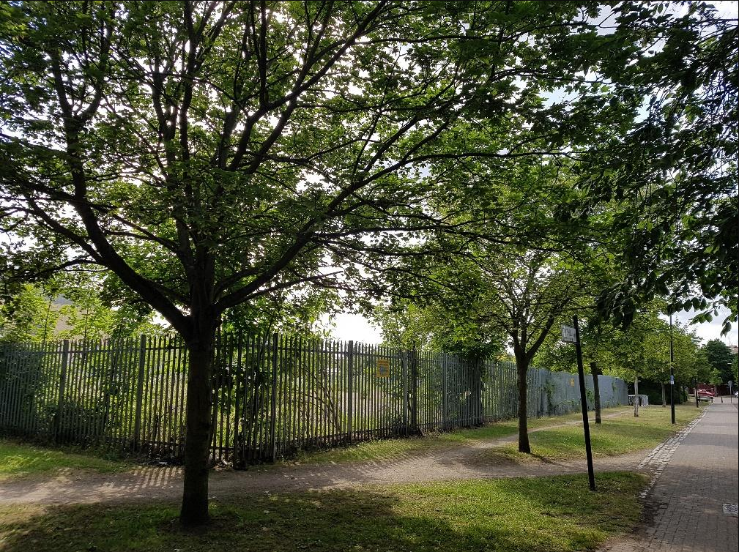

*Figure 2. Russia Walk on Northern boundary (Fencing marks K1 site)*

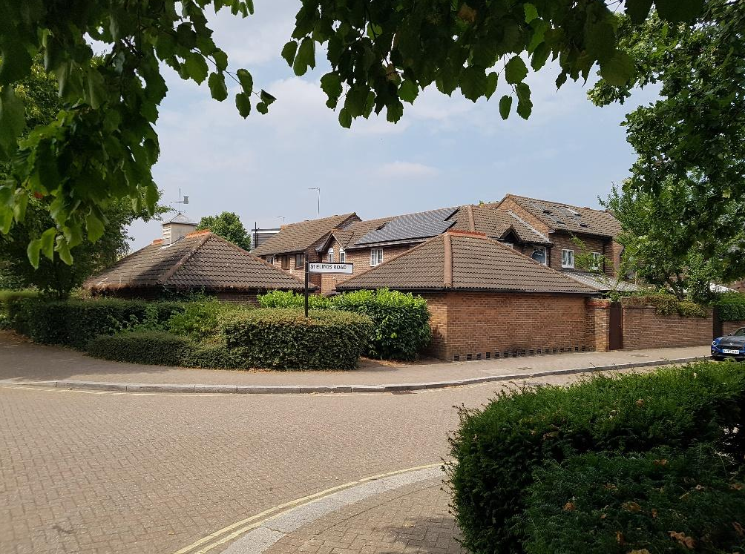

*Figure 3. Nearest housing on St Elmo’s Road are all two storey dwellings, North-west of K1 site..*

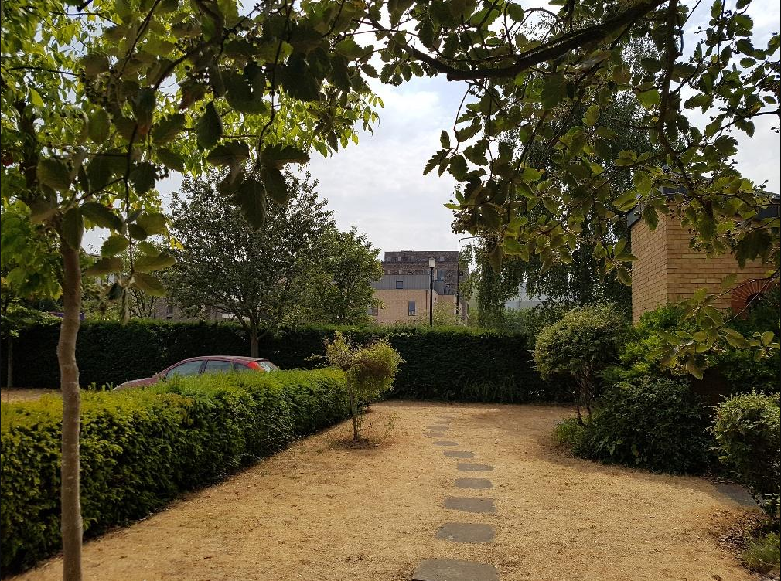

*Figure 4. View from church grounds. Six storey block proposed directly behind thicket hedge in background.*

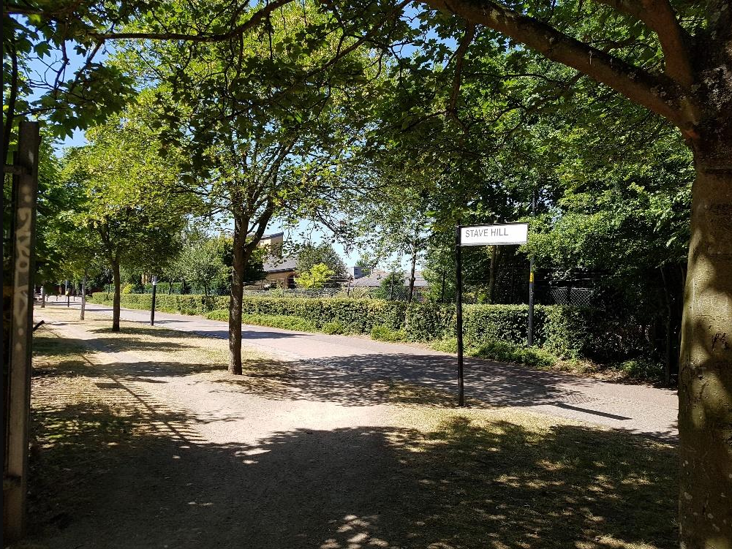

*Figure 5. View on Russia Walk North with Stave Hill Ecology Park entrance on right hand side. This entire pathway entrance will be placed in deep shade. (Note length tree shadowing just after midday)*

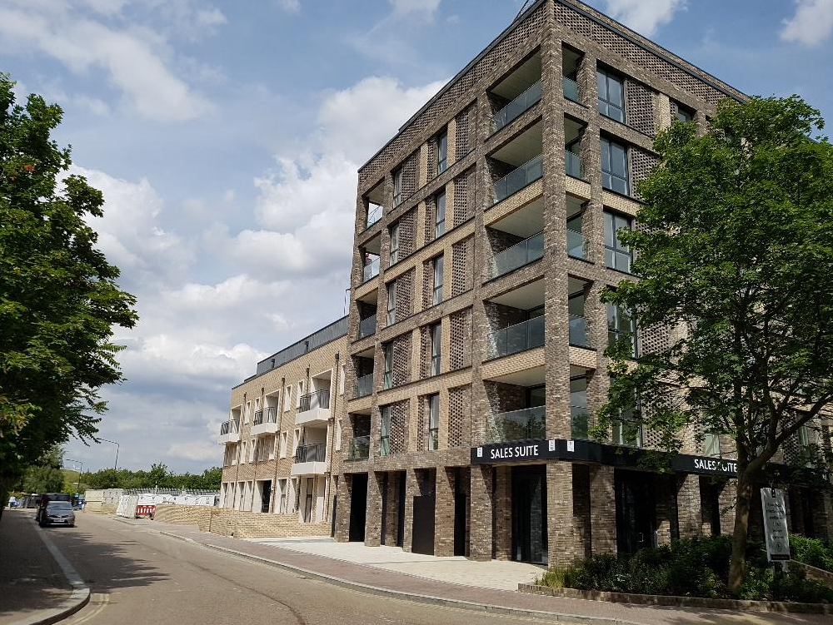

*Figure 6. London Square Development at Roberts Close/Quebec Way. (South side looking North) Note the development drops down to three storey town house size towards K1 site.*

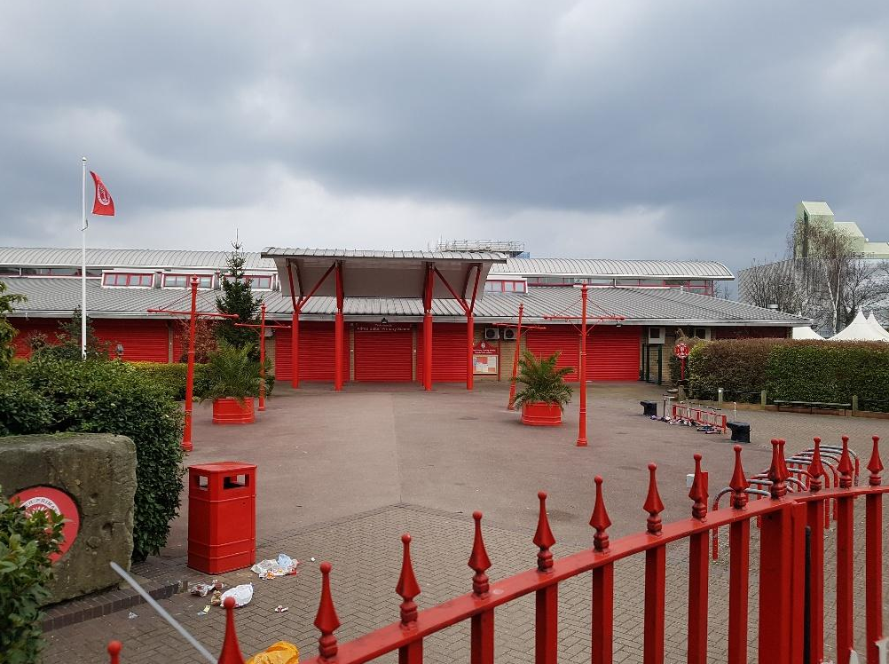

*Figure 7. Alfred Salter Junior School single storey. North-west of the K1 site. The playground of which would be in shade for the morning from the developments shadow.*

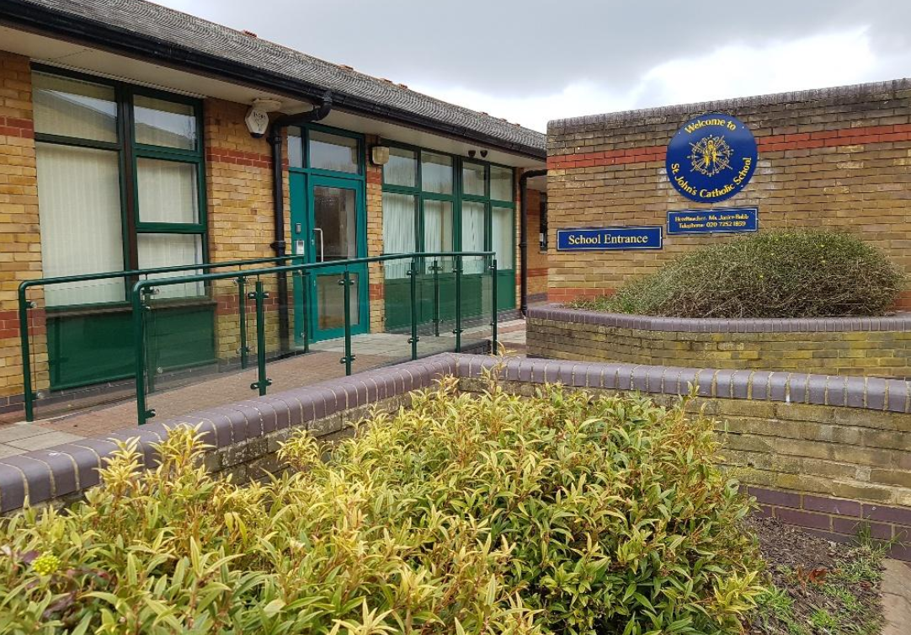

*Figure 8. St John’s Catholic School single storey. north of K1 site.*